Layout Parasitic Extraction and Agent 2 Stop Criteria
Candidate platform: EPC90133 half-bridge development board (2 x EPC2302)
Version: v0.1 Date: 29 September 2026

1 Parasitics That Must Be Extracted
When the GaN FETs switch in a few nanoseconds, every piece of copper and every via in the current path adds inductance, resistance, or capacitance. Together with the device output capacitance, these parasitics set the voltage overshoot, the ringing, and part of the switching loss. Figure 1 shows where each parasitic sits in the half-bridge circuit. Figure 2 shows why the power-loop inductance depends mainly on the loop area formed by the top copper and the return plane.
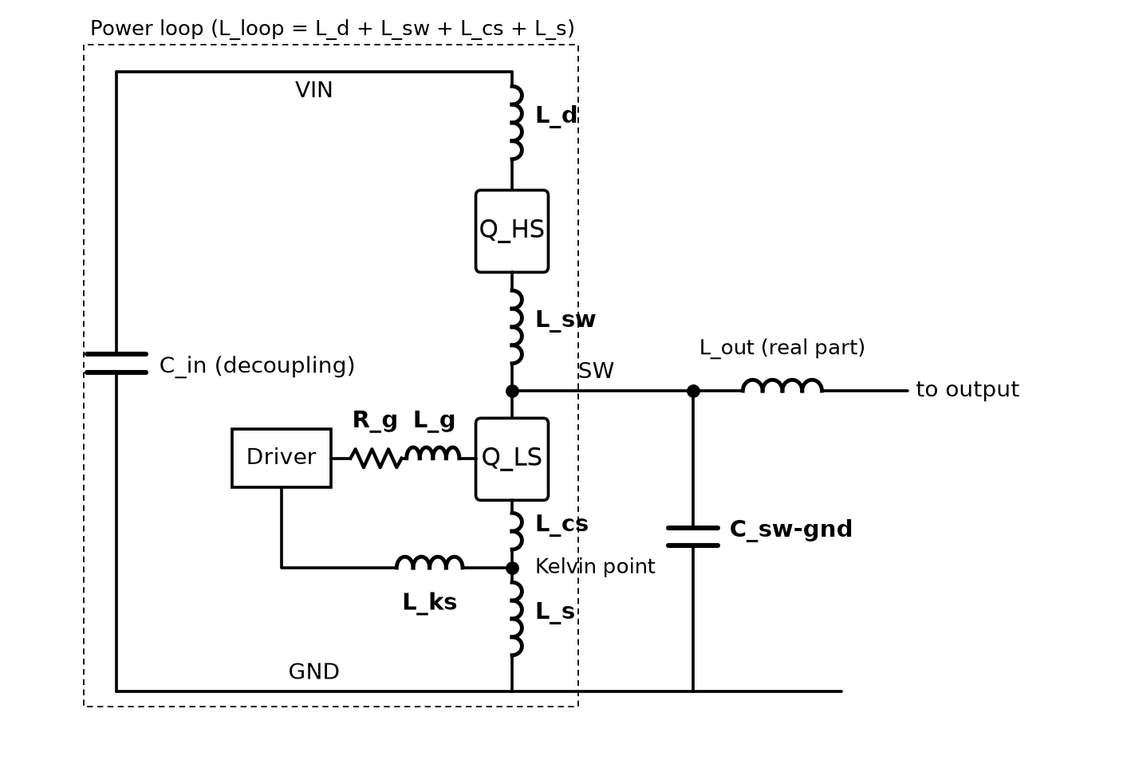
Figure 1 Location of the extracted parasitics in the half-bridge circuit
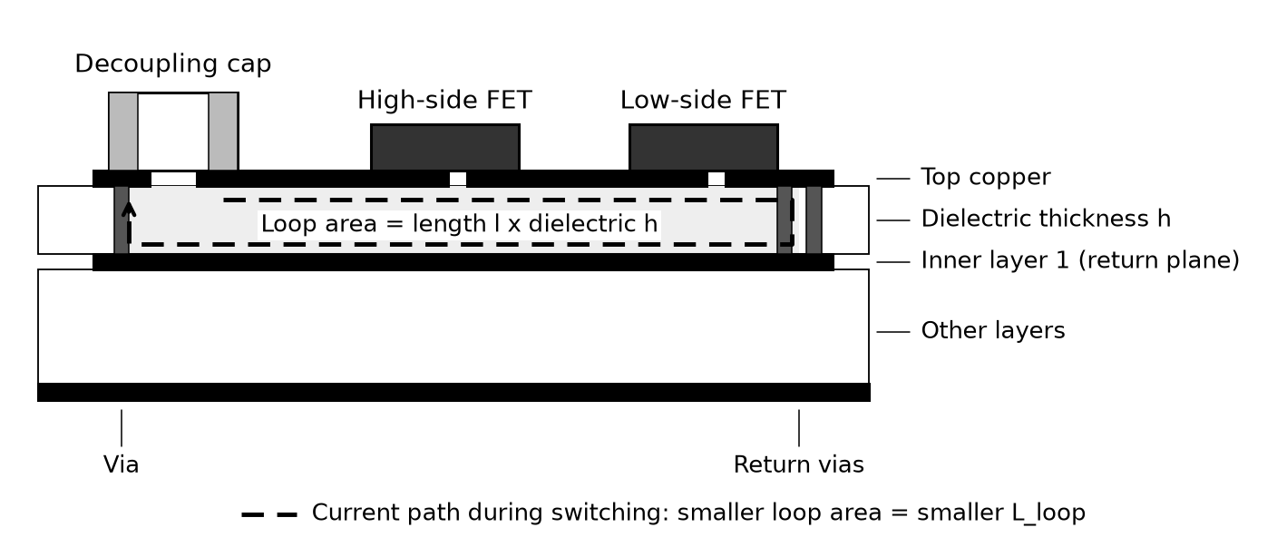
Figure 2 PCB cross-section of the power loop (schematic, not to scale)

1.1 Parasitic list
Group | Parasitic | Location | Why it matters | Priority
Power loop | L_d | Decoupling capacitor (+) to high-side drain | Part of L_loop; sets turn-off overshoot and ringing frequency | Must
 | L_sw | High-side source to low-side drain (switch node) | Part of L_loop | Must
 | L_s | Low-side source through return vias and inner plane to capacitor (-) | Part of L_loop | Must
Common source | L_cs (HS and LS) | Source pad to Kelvin branch point, shared by power current and gate return | Negative feedback of di/dt into the gate; slows switching and adds loss | Must
Gate loop | L_g | Driver output through R_g to gate | Gate ringing and overshoot; GaN gate margin is small | Must
 | L_ks | Kelvin source back to driver ground | Same as L_g | Must
Capacitance | C_sw-gnd | Switch-node copper to ground | Charged and discharged every cycle; adds loss, affects dv/dt and EMI | Must

2 Agent 2 Stop Criteria

2.1 Performance targets (EPC original as baseline)
Metric | Proposed target
Voltage overshoot | Lower than the EPC original
Switching energy Eon + Eoff | Not higher than the EPC original
Estimated efficiency (48 V to 12 V) | Not lower than the EPC original

2.2 Convergence (when to stop)
Metric | Proposed target
Improvement | Less than 1% over 5 consecutive iterations
Human review | Approved by the engineer

3 Method: Extracting Parasitics from the Layout

3.1 Five steps
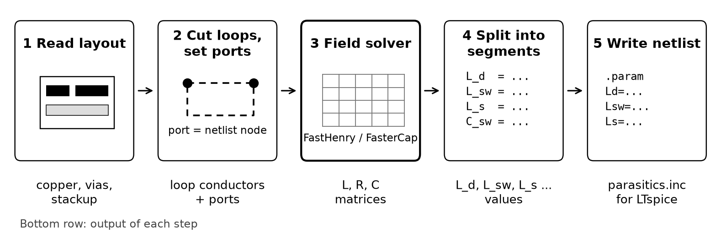
Figure 3 From layout to circuit simulation in five steps
- Read the layout. Take the copper shapes, vias and layers from the KiCad file, plus the board stackup (copper thickness and the thickness of the insulation between layers). The stackup matters most: if the insulation thickness is wrong, the loop inductance is wrong by the same ratio.
- Cut out the loops and set ports. Keep only the copper that carries the switching current (VIN, switch node, ground) and the gate loop. Put a "port" on each FET pad, capacitor pad and driver pin. Each port becomes one node in the circuit.
- Let the field solver calculate. The solver cuts the copper into many small pieces and calculates how they affect each other (Figure 4). It returns tables (matrices) of L, R and C between the ports.
- Split into segment values. Turn the tables into one value per copper segment: L_d, L_sw, L_cs, L_s, L_g, L_ks and C_sw-gnd (see Figure 1). One value per segment tells Agent 2 which piece of copper to change.
- Write the values into the netlist. Save the values in a small parameter file (parasitics.inc). The circuit simulation reads this file, so every new layout only changes this file.

3.2 Software, inputs and outputs
Step | Software | Input | Output
1 Read layout | KiCad (Python interface) | KiCad board file; stackup table | Copper shapes, vias and layers
2 Loops and ports | Python script | Copper shapes; list of ports | Input files for the two solvers
3 Calculate L, R | FastHenry2 (free) | Conductor segments, ports, frequency | L and R table
3 Calculate C | FasterCap (free) | Copper surfaces, insulation material | C table
4 Segment values | Python script | L, R and C tables | L_d, L_sw, L_cs, L_s, L_g, L_ks, C_sw-gnd
5 Simulate | LTspice + PyLTSpice | parasitics.inc; half-bridge circuit; EPC device model | Switching waveforms: overshoot, ringing, loss

EPC90133 product page (schematic, Gerber, BOM, Altium request, price and stock), https://epc-co.com/epc/products/evaluation-boards/epc90133

